Parent Initial Order Submitted by Parent in Digital Cookie and Sent to Girl Initial Order Record in eBudde™ With Girl Delivery

There is now a new feature which allows a parent in Digital Cookie to submit an initial order for the girl that will post to the girl’s initial order record. To allow this to work the troop will have a parent initial order deadline date of January 28.
Parent Initial order submission in Digital Cookie is optional; the process allows information to flow over to help reduce your data entry for the girl order but keep in mind, you are allowed to update the numbers. So, if a parent submits from the Digital Cookie system and then texts you later to add additional cookies to the girl order, you will be allow to make that change in eBudde as long as you have not submitted your order in eBudde yet. If the parent does not submit the order by the parent initial order deadline date, Digital Cookie will not allow the order to be sent and parent will now have to communicate with troop leader directly.
To accommodate this new process, eBudde now has messaging on the initial order tab to indicate if initial order for the girl has been saved, needs review, review parent IO in red, and review parent IO in orange.
Let’s walk through the proper process. The troop leader is expecting orders to be submitted by parents from the Digital Cookie system. You will go to the Init. Order tab in eBudde. You will see a list of your girls. If the messaging says Needs Review that means that nothing has been done for this girl yet. If you click the order card row on the entry screen, all the numbers will be zero. Your job will be to wait until the parent's initial order comes in, review the numbers, and save.
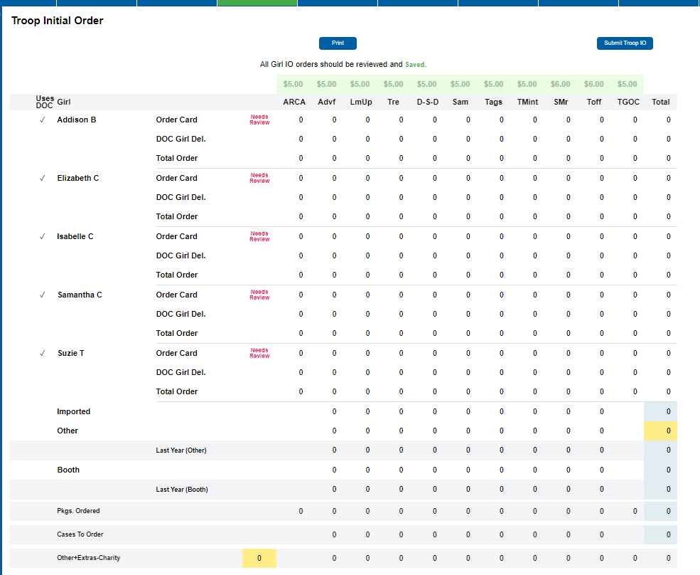

When the parent sends the initial order from Digital Cookie to eBudde, the messaging will change to let you know that eBudde got the order. It will go from Needs Review to Review Parent IO.

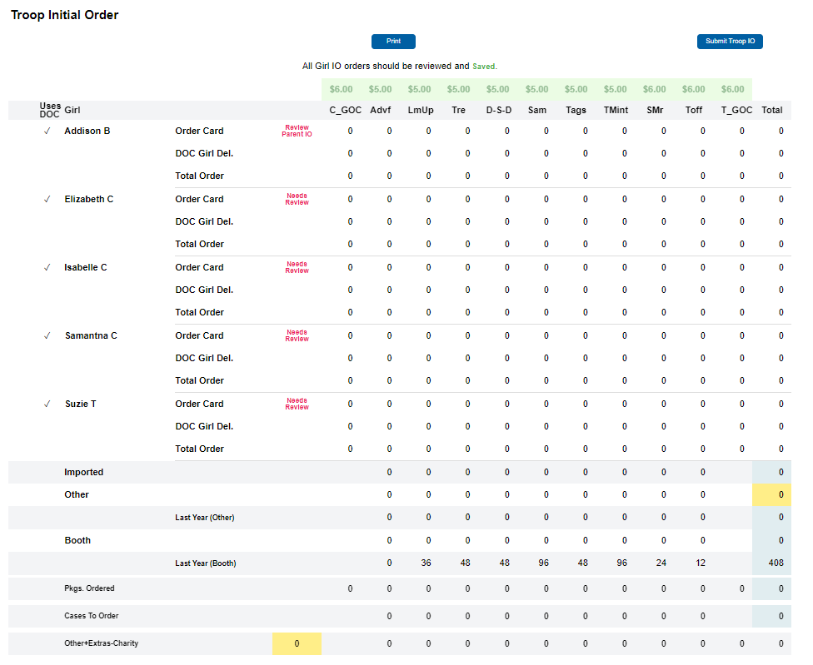

You must review the order. Open the order by clicking in the order card row to open up the editing box. The order will display with the numbers sent over from Digital Cookie. You can leave as is or make updates to these numbers up until the time you submit your troop order.
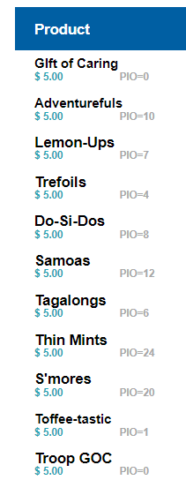
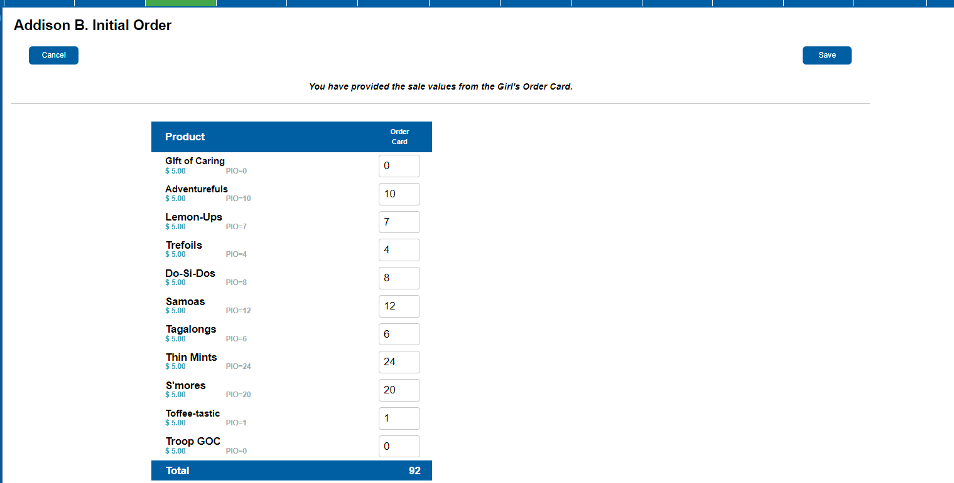

You will notice that there is PIO= under the product name in grey. This tells you the packages that were sent from the parent in the Digital Cookie system. If you update the numbers in the order, you will always be able to see the original numbers that were sent. You review the order and click Save.
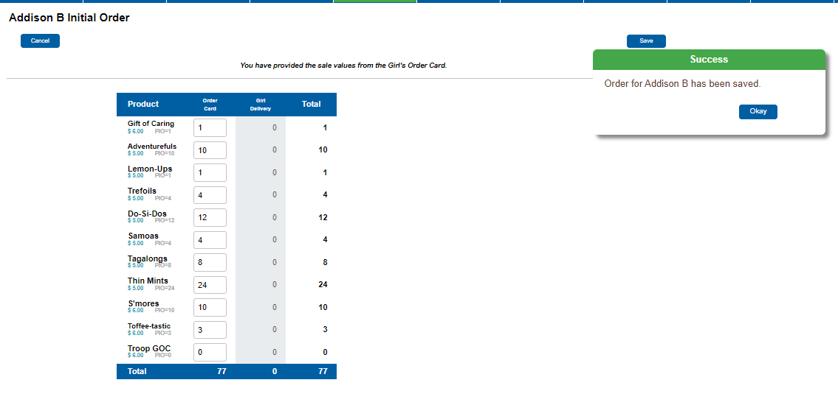

This will return you to the Init, Order recap screen. You will now see that the girl’s initial order has been Saved.

If you open the order card row, you will notice that eBudde tells you that you have:

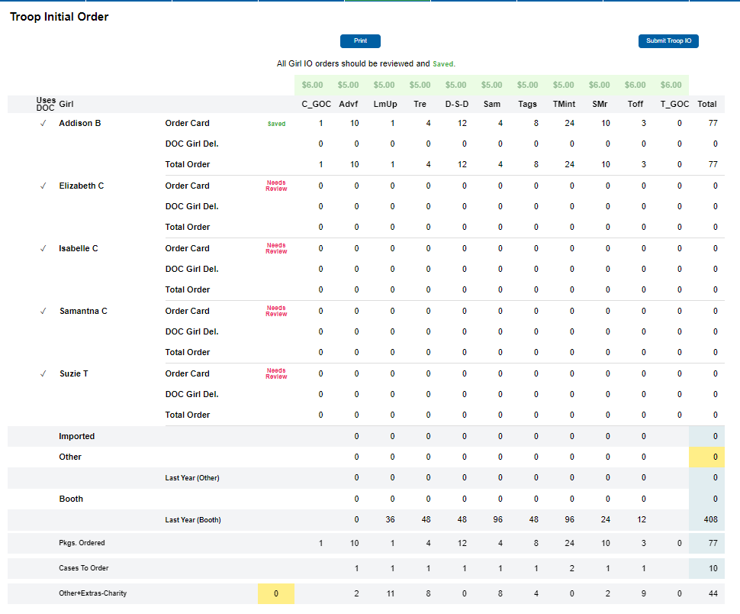

You will continue to do this for each girl that has submitted a parent initial order. If the parent does not submit an initial order, you will open the order card row for the girl, enter in the packages manually and save the girl’s order. If there are changes to any order, you open the girl by clicking the order card row and make those updates and save. You may not have a girl with an order. That is ok. You do not need to open her order card row and save. You can save all zeroes, but it is not necessary. You will submit your order when you are ready and before the troop initial order deadline of February 1, 2024, by 11:59pm. Once you submit, the numbers cannot be changed.

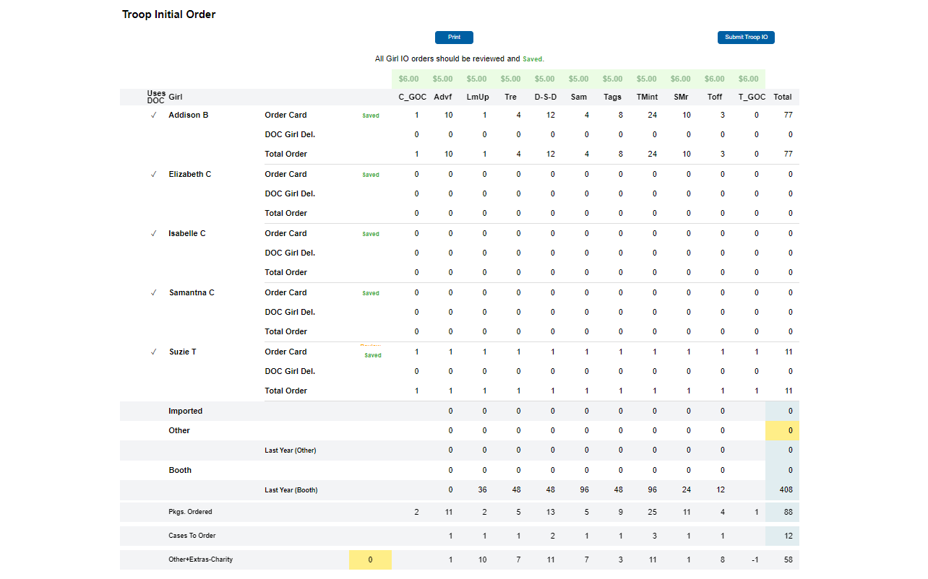

So, what happens if things are not done in order?
What if you submit earlier than the parent initial order deadline date? If you submit too early without changing the parent initial order date, the parents will not know that their orders are not going to be part of the initial order. eBudde will get the data and there is a report that will let you know that the order was not processed as part of the initial order.

What if you enter numbers in the order card row and then the parent initial order is submitted by the parent? eBudde is going to message you to Review Parent IO in orange to let you know that you have keyed in numbers and now the parent IO came in after those numbers were saved. When you click the order card row there is additional messaging from eBudde as to what is going on. Let’s look at that.
A parent initial order came in from Digital Cookie for Suzie. The troop cookie chair had already keyed one package of each variety for her initial order and saved it. Now the troop cookie chair has a decision to make. Do I take what I keyed or use the parent initial order?

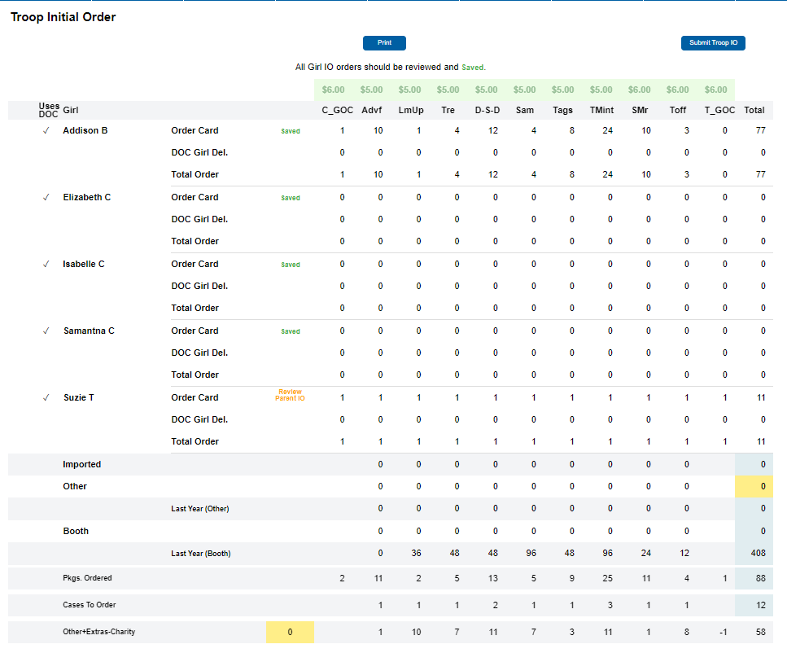

Click the order card row to open up the record. You will see messaging and numbers for what is currently keyed in and what the parent submitted.

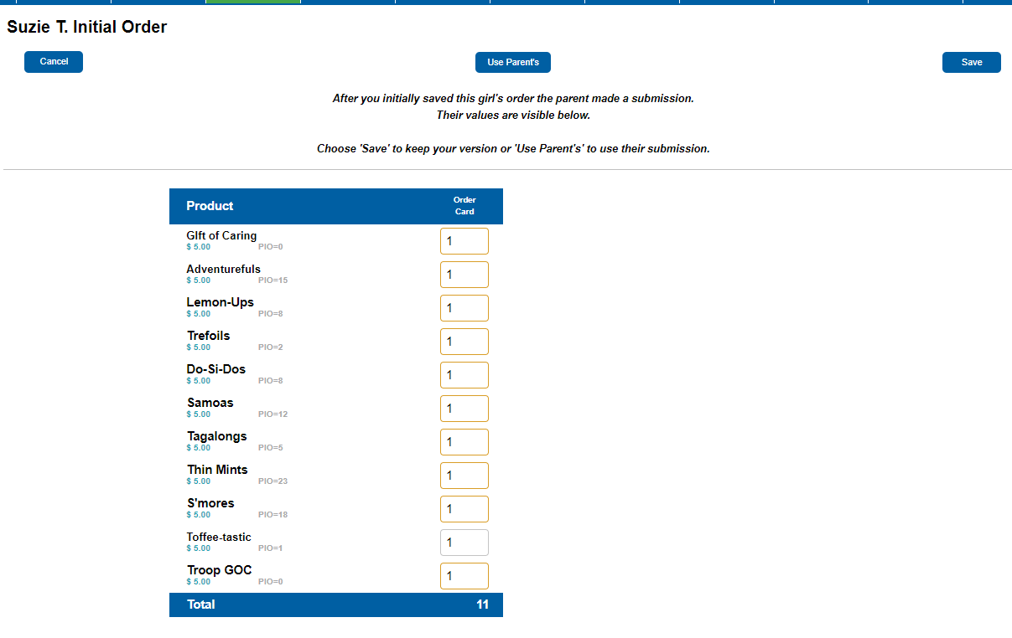

So let’s review this page. You will see a new button that says Use Parent’s. And below that it states that you had already submitted some numbers for this girl. To easily update all the numbers to use what was submitted by the parent, click the Use Parent’s button. It will automatically do a save when you click this button,
If you do not want to use the parent’s numbers and have no changes, just click Save.
You will also notice that the current numbers are in boxes that are orange. This is to clue you in that there is something different about this girl’s order. Mainly, that the numbers were keyed first and the parent initial order came in later.

